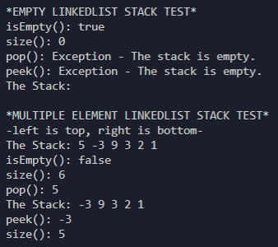**QUESTION 1 TEST CASE RESULTS (LinkedListStackTest.java)**

**QUESTION 2 TEST CASE RESULTS (ArrayListStackTest.java)**

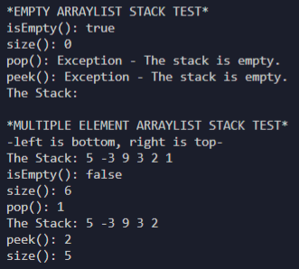

**QUESTION 3 TEST CASE RESULTS (LinkedListQueueTest.java)**

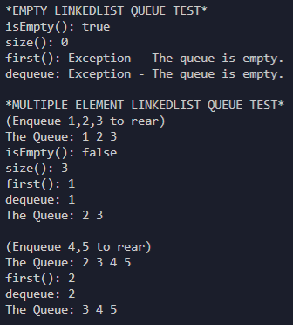

**QUESTION 4 TEST CASE RESULTS (ArrayListQueueTest.java)**

